DAA LAB — COMPLETE LAB FILE
Complete Lab File containing all sorting algorithms, Fibonacci (all 3 programs), experimental analysis, complexity comparison, graphs/visualizations, observations, screenshots and GitHub links.
1. Sorting Algorithms
def bubble_sort(a):
a=a.copy()
for i in range(len(a)-1):
swapped=False
for j in range(len(a)-i-1):
if a[j]>a[j+1]: a[j],a[j+1]=a[j+1],a[j]; swapped=True
if not swapped: break
return a

def selection_sort(a):
a=a.copy()
for i in range(len(a)-1):
k=min(range(i,len(a)),key=a.__getitem__)
a[i],a[k]=a[k],a[i]
return a

def insertion_sort(a):
a=a.copy()
for i in range(1,len(a)):
key=a[i]; j=i-1
while j>=0 and a[j]>key: a[j+1]=a[j]; j-=1
a[j+1]=key
return a

def merge_sort(a):
if len(a)<=1: return a.copy()
m=len(a)//2; l=merge_sort(a[:m]); r=merge_sort(a[m:])
out=[]; i=j=0
while i<len(l) and j<len(r):
if l[i]<=r[j]: out.append(l[i]); i+=1
else: out.append(r[j]); j+=1
return out+l[i:]+r[j:]

def quick_sort(a):
if len(a)<=1: return a.copy()
pivot=a[len(a)//2]
return quick_sort([x for x in a if x<pivot])+[x for x in a if x==pivot]+quick_sort([x for x in a if x>pivot])

def heap_sort(a):
import heapq
h=a.copy(); heapq.heapify(h)
return [heapq.heappop(h) for _ in range(len(h))]

if __name__=="__main__":
data=[64,25,12,22,11,90,34]
alg={"Bubble Sort":bubble_sort,"Selection Sort":selection_sort,"Insertion Sort":insertion_sort,"Merge Sort":merge_sort,"Quick Sort":quick_sort,"Heap Sort":heap_sort}
print("Python Sorting Algorithm Demonstration")
for n,f in alg.items(): print(f"{n:18}: {f(data)}")
Screenshot

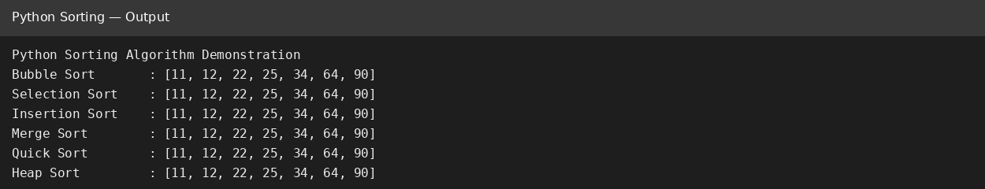
GitHub Link
____________________________________________
Paste the GitHub repository/file URL after uploading the Python code.
2. Fibonacci — All 3 Programs
def fibonacci_recursive(n):
if n<=1: return n
return fibonacci_recursive(n-1)+fibonacci_recursive(n-2)

def fibonacci_iterative(n):
a,b=0,1
for _ in range(n): a,b=b,a+b
return a

def fibonacci_dynamic(n):
if n<=1: return n
dp=[0]*(n+1); dp[1]=1
for i in range(2,n+1): dp[i]=dp[i-1]+dp[i-2]
return dp[n]

if __name__=="__main__":
n=20
print(f"Python Fibonacci Programs (n={n})")
print("Recursive :",fibonacci_recursive(n))
print("Iterative :",fibonacci_iterative(n))
print("Dynamic Programming :",fibonacci_dynamic(n))
Screenshot

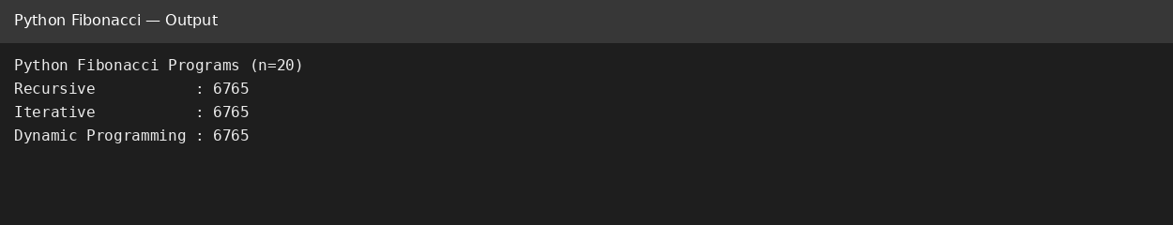
GitHub Link
____________________________________________
Paste the GitHub repository/file URL after uploading the Python code.
3. Experimental Analysis
import time,tracemalloc,random
from sorting_algorithms import bubble_sort,selection_sort,insertion_sort,merge_sort,quick_sort,heap_sort
alg={"Bubble Sort":bubble_sort,"Selection Sort":selection_sort,"Insertion Sort":insertion_sort,"Merge Sort":merge_sort,"Quick Sort":quick_sort,"Heap Sort":heap_sort}
sizes=[100,500,1000]
random.seed(42)
print("Algorithm,Size,Condition,Time_ms,Peak_Memory_KB")
for n in sizes:
data={"Sorted":list(range(n)),"Reverse-Sorted":list(range(n,0,-1)),"Random":[random.randint(0,100000) for _ in range(n)]}
for name,f in alg.items():
for cond,a in data.items():
ts=[]; ms=[]
for _ in range(3):
tracemalloc.start(); s=time.perf_counter(); f(a); ts.append((time.perf_counter()-s)*1000)
_,peak=tracemalloc.get_traced_memory(); tracemalloc.stop(); ms.append(peak/1024)
print(f"{name},{n},{cond},{sum(ts)/3:.4f},{max(ms):.2f}")
Screenshot

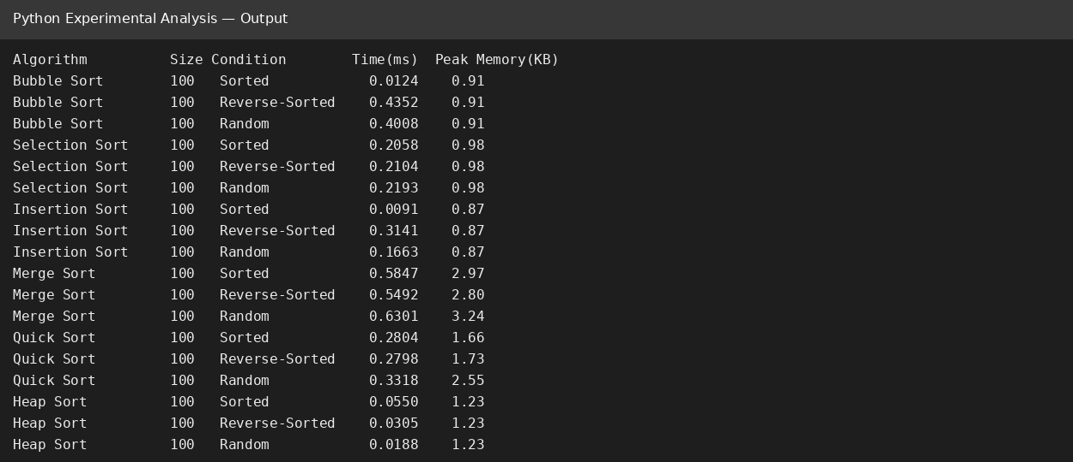
The experiment uses different input sizes and sorted, reverse-sorted and random conditions. Execution time is measured using time.perf_counter(), and peak memory is measured using tracemalloc.
GitHub Link
____________________________________________
Paste the GitHub repository/file URL after uploading the Python code.
4. Complexity Comparison
Algorithm | Best | Average | Worst | Space
Bubble Sort | O(n) | O(n²) | O(n²) | O(1)
Selection Sort | O(n²) | O(n²) | O(n²) | O(1)
Insertion Sort | O(n) | O(n²) | O(n²) | O(1)
Merge Sort | O(n log n) | O(n log n) | O(n log n) | O(n)
Quick Sort | O(n log n) | O(n log n) | O(n²) | O(n)*
Heap Sort | O(n log n) | O(n log n) | O(n log n) | O(n)*
Fibonacci Recursive | O(2ⁿ) | O(2ⁿ) | O(2ⁿ) | O(n)
Fibonacci Iterative | O(n) | O(n) | O(n) | O(1)
Fibonacci Dynamic Programming | O(n) | O(n) | O(n) | O(n)

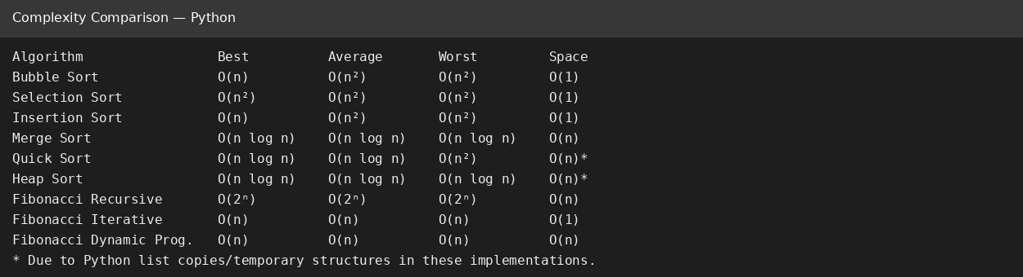
5. Graphs and Observations

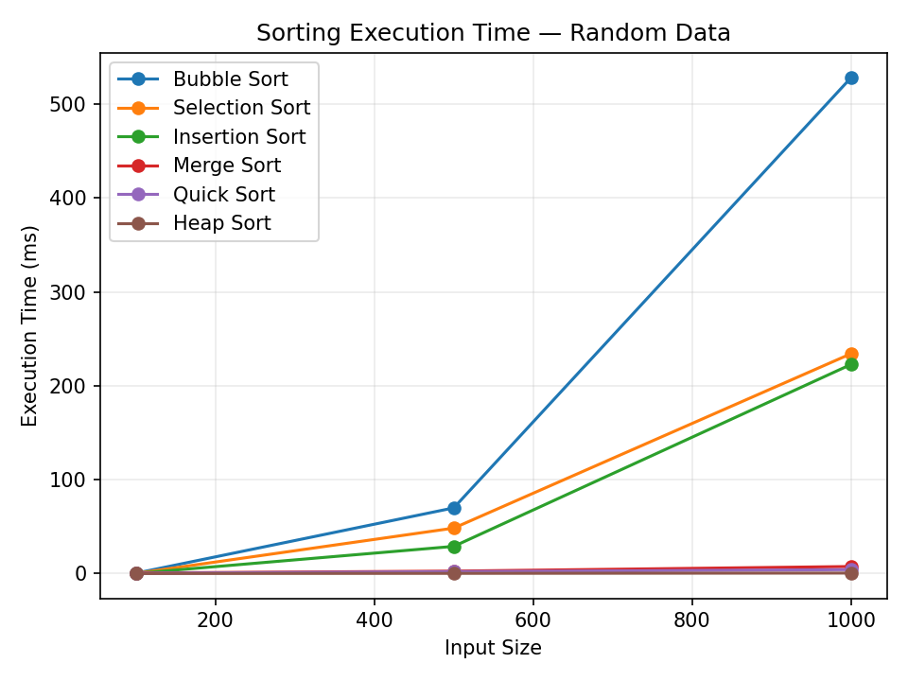
Observation: O(n²) sorting algorithms grow much faster with input size than O(n log n) algorithms.

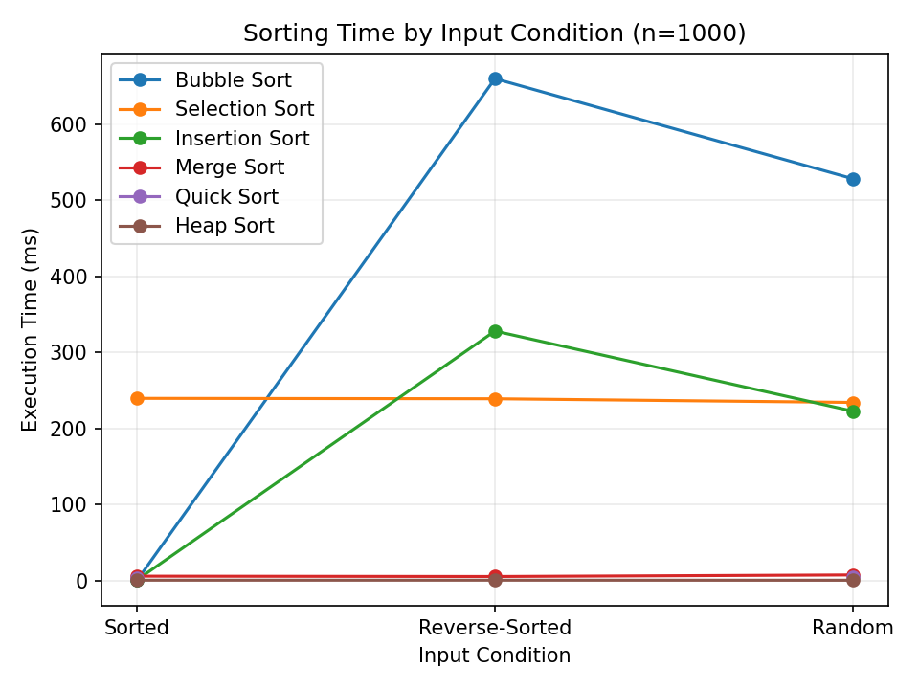
Observation: Input order strongly affects Bubble and Insertion Sort.

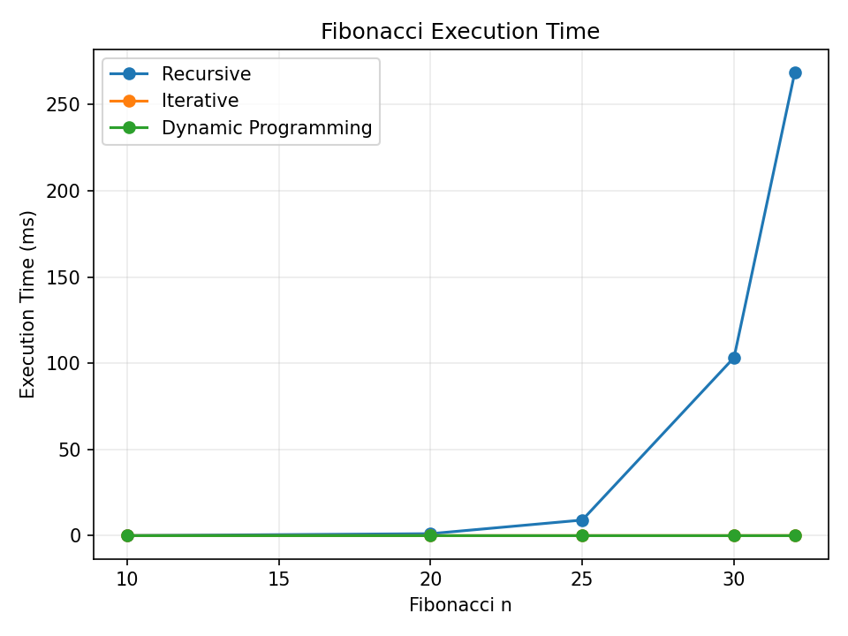
Observation: Recursive Fibonacci grows rapidly, whereas Iterative and Dynamic Programming are much faster.

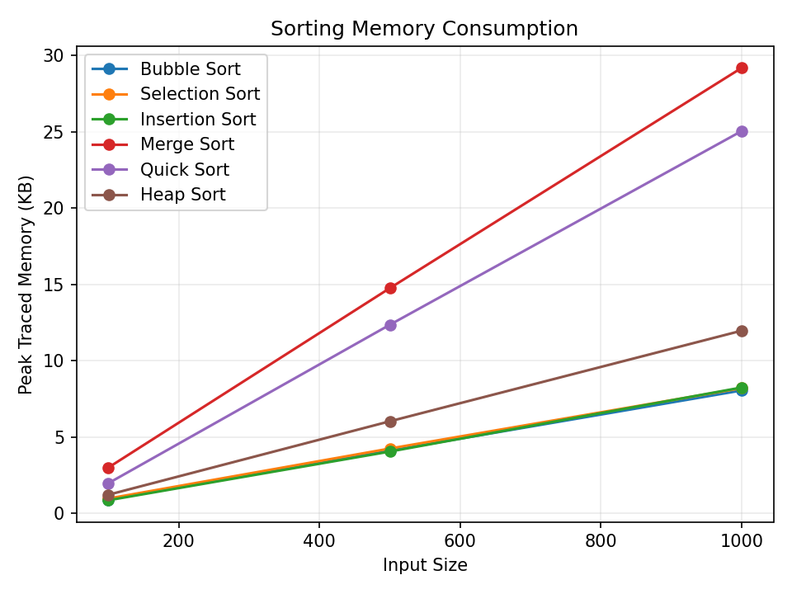
Observation: Python's actual traced memory is affected by list creation and temporary structures.
Conclusion
The experimental results demonstrate the importance of algorithmic complexity. O(n log n) sorting algorithms are generally better for larger inputs, and iterative/dynamic-programming Fibonacci avoids repeated work.
GitHub Link
____________________________________________
Paste the GitHub repository/file URL after uploading the Python code.

